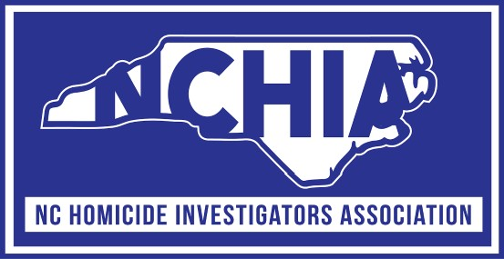

2025 Fall Training Conference

October 20, 2025 through October 24, 2025

Carolina Beach, North Carolina

**Sunday, October 19, 2025**

7:00 pm – 8:00 pm **Early Registration** – Lobby

**Monday, October 20, 2025**

7:00 am – 8:00 am **Registration**

8:00 am – 8:30 am **Opening Remarks**, Derek B. Moore

8:30 am – 12:00 pm Boston Marathon Bombing

Detective Dave MacNeil (Retired), Watertown Police Dept. MA

12:00 pm – 1:00 pm Lunch on your own

1:00 pm – 5:00 pm Tim Smart Murder - NC SBI Hunter Whitt / NCOME Becky Jumonville

**Tuesday, October 21, 2025**

8:00 am – 10:00 pm Gianna Delago – The Girl in the Box

Detective Kaylyn Stewart / Detective Charlie Wade

Highpoint Police Department

10:00 am – 12:00 pm Limitations of Medicolegal Autopsy and the Critical Role of Investigations / Dr. Kimberly Janssen, Dep. Chief Medical Examiner

12:00 pm – 1:00 pm Lunch on your own

1:00 pm – 3:00 pm Charlotte PD and US Marshall Task Force LEO Ambush

Sgt. Brad Dunn / Det. Jackie Carter / CMPD Homicide Unit

3:00 pm – 5:00 pm Staged Suicide Investigation / CMPD

**Wednesday, October 22, 2025**

8:00 am – 12:00 pm Murdaugh Murders

SLED Special Agent David Owen (Retired)

12:00 pm – 1:00 pm Lunch on your own

1:00 pm – 5:00 pm Open Case Review

**Thursday, October 23, 2025**

8:00 am – 12:00 am Courtney Palmer murder / First 48 episode

Detective Jason White / Tulsa P.D.

12:00 pm – 1:00 pm Lunch on your own

1:00 pm – 2:00 pm Business Meeting

2:00 pm – 4:00 pm Child Death Investigation   
 Jordan Hales / NC Medical Examiners Office

**Friday, October 24, 2025**

8:00 am – 10:00 pm Assisted Suicide / NCIS

10:00 am – 11:00 pm Lt. Daniel Johnson / Fayetteville P.D.

11:00 pm – 11:30 pm Closing remarks