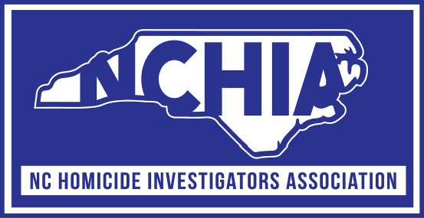

2026 Spring Training Conference
April 20, 2026 through April 24, 2026
Cherokee, North Carolina

Sunday, April 19, 2026

7:00 pm – 8:00 pm Early Registration – Lobby

Monday, April 20, 2026

7:00 am – 8:00 am Registration

8:00 am – 8:30 am Opening Remarks, Derek B. Moore

8:30 am – 12:00 pm Laken Riley Homicide Investigation
Agent Lucas Beyer – Georgia Bureau of Investigation

12:00 pm – 1:00 pm Lunch on your own

1:00 pm – 5:00 pm Delphi Double Homicide
Lt. Jerry Holeman – Indiana State Police

Tuesday, April 21, 2026

8:00 am – 10:00 am Quadruple Arson Homicide Investigation
Neil Baker – Denver Police Department

10:00 am – 12:00 pm Staged Suicide Homicide Investigation
Capt. Bryan Crum – Charlotte-Mecklenburg Police Department

12:00 pm – 1:00 pm Lunch on your own

1:00 pm – 5:00 pm Death Investigation / Equivocal Death
Lt. Jeff Locklear – Fayetteville Police Department

Wednesday, April 22, 2026

8:00 am – 12:00 pm Courtney Palmer murder / First 48 episode
Detective Jason White / Tulsa Police Department

12:00 pm – 1:00 pm Lunch on your own

1:00 pm – 5:00 pm Open Case Review

Thursday, April 23, 2026

8:00 am – 12:00 pm 2023 Wadesboro Mass Shooting: Lessons in Leadership, Staffing and Survival
Lt. Tamika Nolen – Wadesboro Police Department

12:00 pm – 1:00 pm Lunch on your own

1:00 pm – 1:30 pm Business Meeting

1:30 pm – 3:30 pm Christian Willard Homicide
Mike Johnston – SBI, Winston Salam Police Department,
Forsyth County Sheriff’s Office

3:30 pm – 5:00 pm TBD

Friday, April 24, 2026

8:00 am – 10:00 am K-9 presentation – Electronic Sniffing Dog
Special Agent Ellen Huggins - NCIS

10:00 am – 11:00 am Officer Wellness
Lt. Daniel Johnson - Fayetteville Police Department

11:00 am – 11:30 am Closing remarks

